BRACT’s
Vishwakarma Institute of Technology, Pune
Practical Implementation Sheet
Department: CSE-AI Semester: 5 Academic Year: 2026-27
Division: E Batch: 1 Practical No: 6
Roll no: 42 PRN No: 12414728 Name of Student: Saachi Laturiya
Subject Name : Deep Learning

Problem Statement : Design and implement a Convolutional Neural Network (CNN) for image classification using the Tomato or Soybean disease dataset.
Algorithm :
- Import the required libraries for image processing, visualization, CNN implementation, and performance evaluation.
- Download and load the New Plant Diseases Dataset containing multiple plant species and disease classes.
- Identify the training and validation directories and load the images using image_dataset_from_directory().
- Resize all images to 64 × 64 pixels and divide them into batches.
- Identify the different disease classes and visualize sample images from the dataset.
- Analyze and visualize the distribution of images among the different disease classes.
- Normalize the image pixel values from the range 0–255 to 0–1.
- Construct a Convolutional Neural Network consisting of:
  - Convolutional layers for feature extraction
  - Max-pooling layers for dimensionality reduction
  - Global Average Pooling
  - Dense layer for classification
  - Softmax output layer for multiclass classification
- Compile the CNN using the Adam optimizer, sparse categorical cross-entropy loss function, and accuracy as the evaluation metric.
- Train the CNN using the training dataset for a specified number of epochs and validate it using the validation dataset.
- Record the training and validation accuracy and loss during the training process.
- Visualize the training and validation accuracy to analyze the learning performance of the model.
- Visualize the training and validation loss to analyze model convergence and possible overfitting.
- Evaluate the trained CNN using the validation dataset and calculate the final validation accuracy and loss.
- Generate predictions for the validation images using the trained CNN.
- Generate a classification report containing precision, recall, F1-score, and support for each disease class.
- Generate and visualize the confusion matrix to analyze correctly and incorrectly classified plant disease classes.
- Analyze the final accuracy and evaluation results to determine the overall performance of the CNN.

Code :
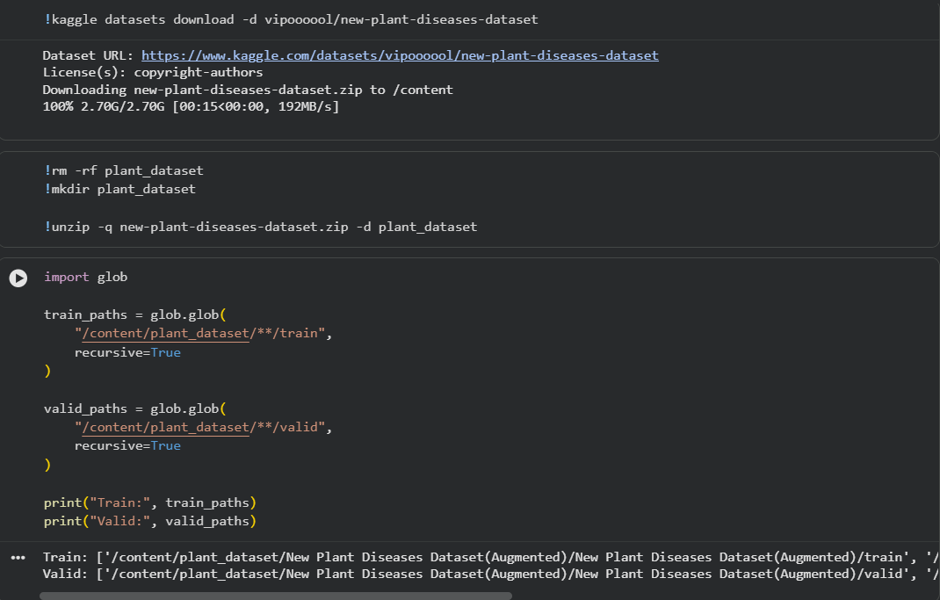
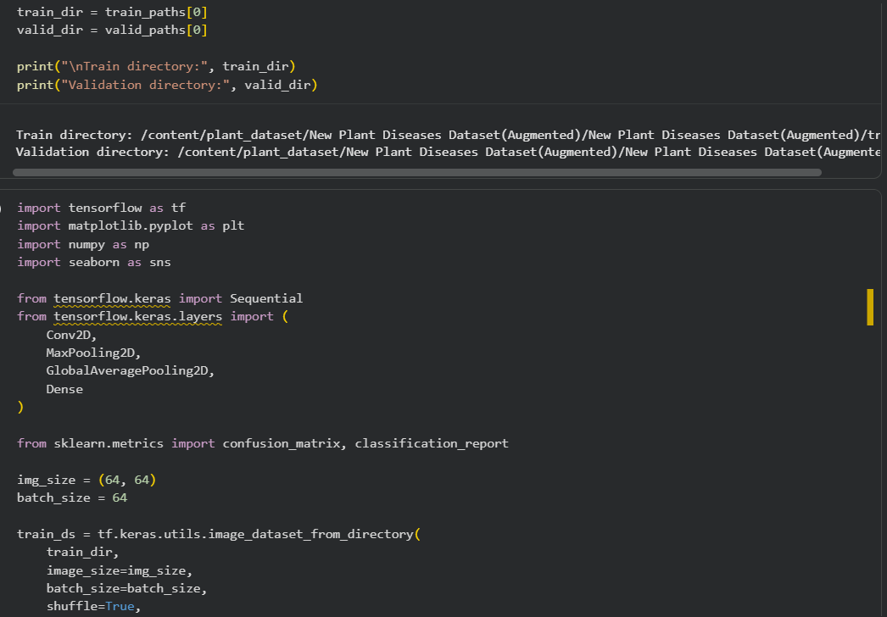
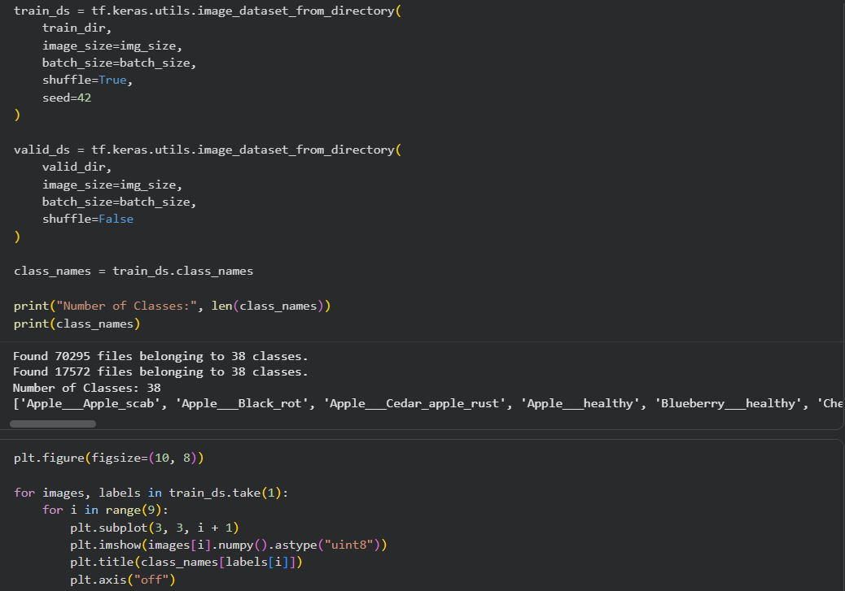
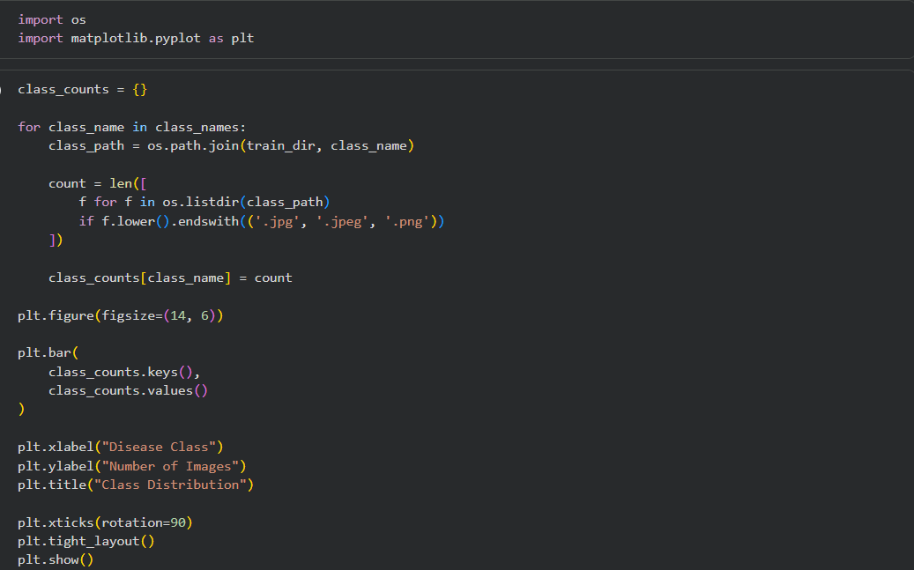
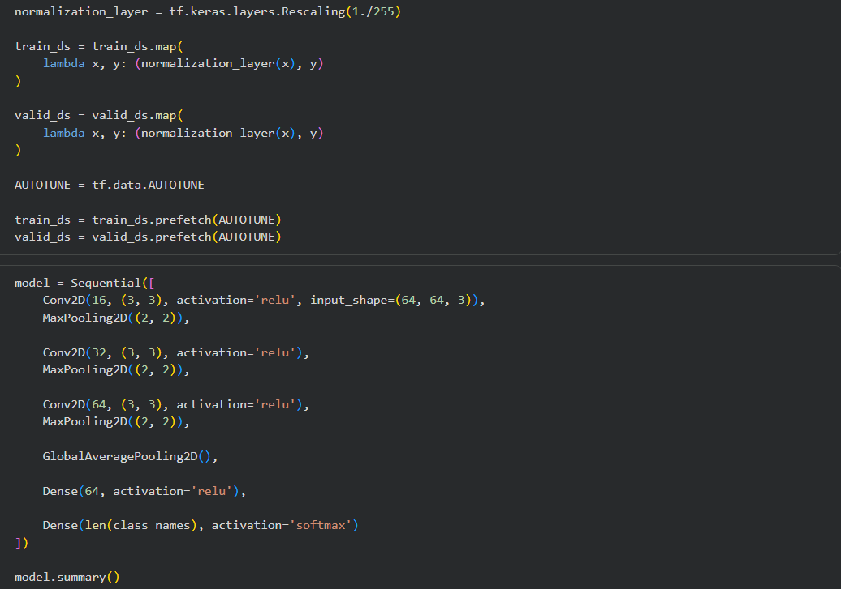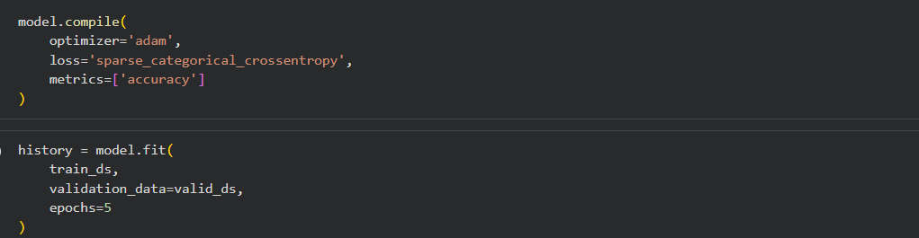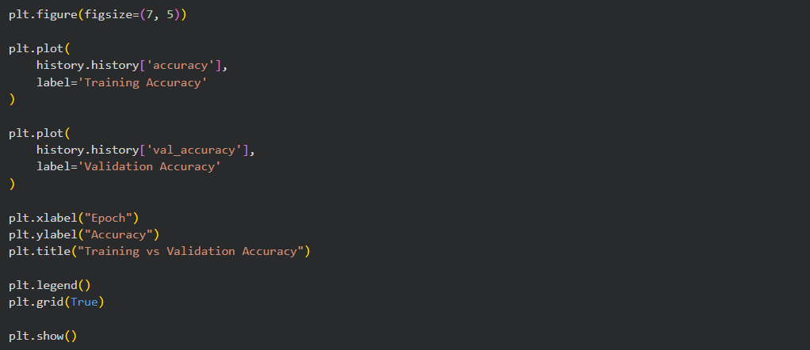
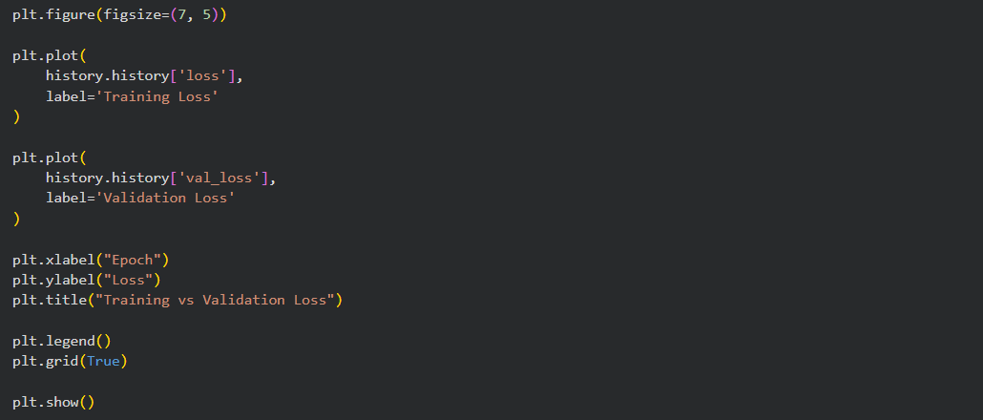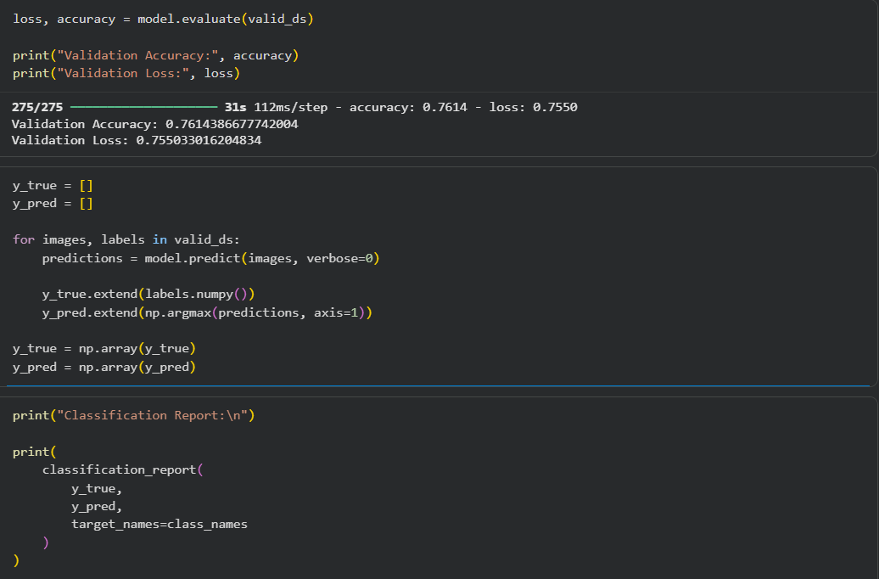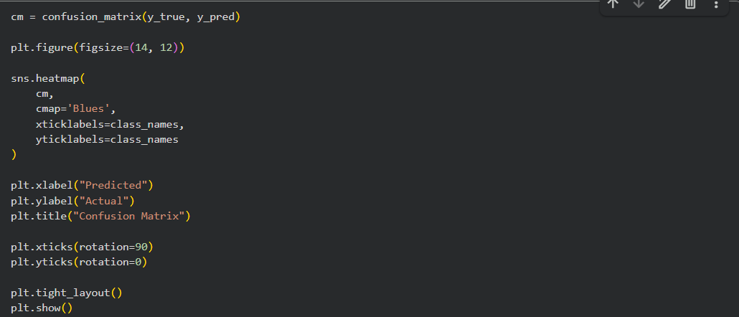
Output :
    - Sample Images
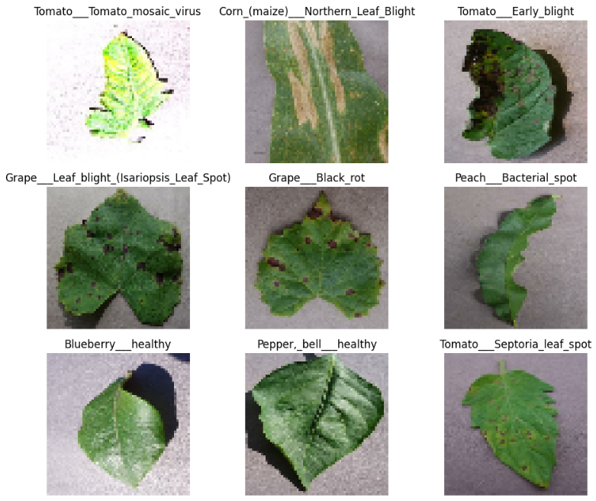
    - Class Distribution
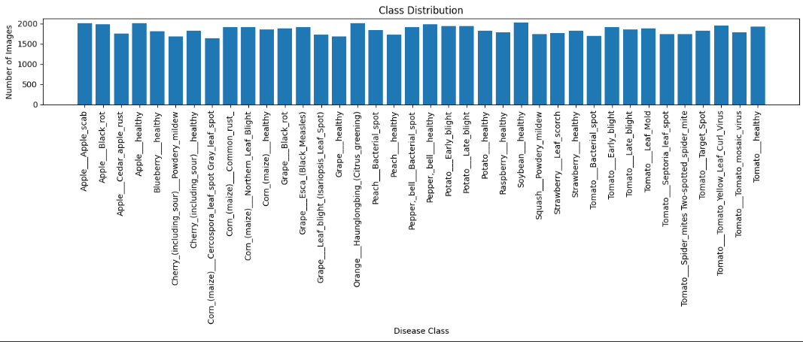

    - Training vs Validation Accuracy
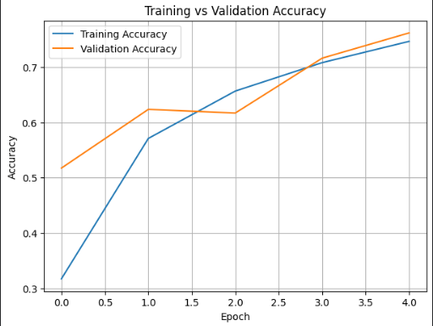
    - Training vs Validation Loss
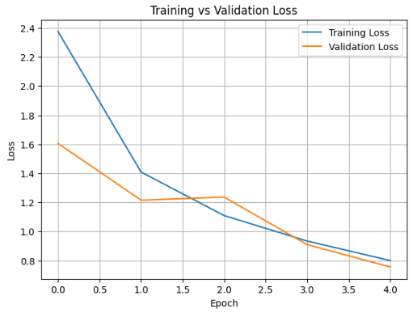

    - Classification Report
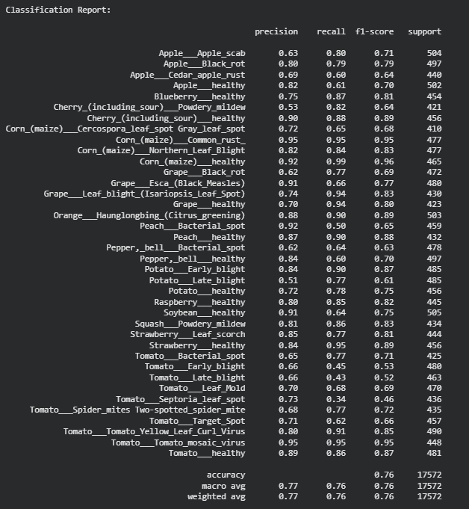

    - Confusion Matrix
